**Documentation for ID Card Generator Application**

**Introduction**

This is general documentation for my assignment project “ ID card Generator Application .”

During the project I am using bootstrap ,css,html,js and php Laravel Framework for the project .

***Project Title:*** ID Card Generator Application

***Objective:***  
Develop a web application using Laravel 11 that allows users to create and print ID cards dynamically.

***Requirement:***

1. In the admin panel there shall be options for Photo upload, Name, Address, DOB, Card Expiry Date and other details input that are required for a ID card
2. Create a view for the ID card layout.
3. Implement functionality to fetch data from the database and display it on the ID card.
4. Add a print button to allow users to print the ID card.
5. Create a schema to store user details and photos, and develop models for dynamic data interaction.
6. Implement user authentication.
7. Ensure the application is fully dynamic, not hardcoded.

# Use case for this ID Card Generator Application

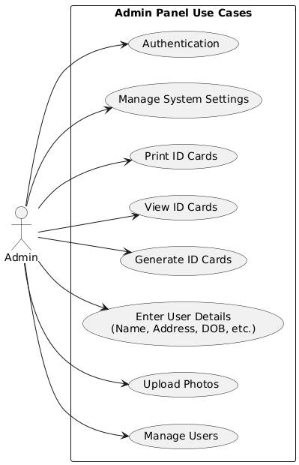

**­­­­**

**System Sequence Diagram**

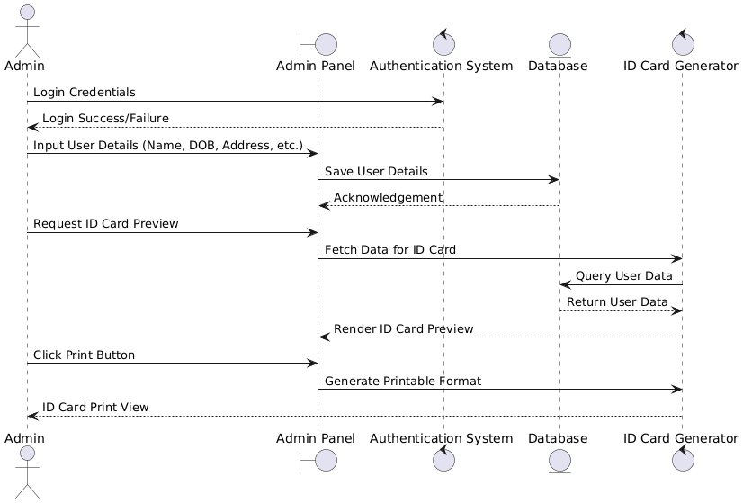

**Class Diagram**

